EtherCAT Technology Group welcomes WITRON as 5,000th member

At the SPS IPC Drives 2018 exhibition in Nuremberg, Germany, the EtherCAT Technology Group (ETG) achieved two remarkable milestones: It celebrated exactly 15 years since ETG was established with 33 founding members, and with the addition of WITRON Logistics + Informatics GmbH, ETG welcomed its 5,000th member.

The intralogistics system provider WITRON Logistics + Informatics GmbH is member number 5,000 of the EtherCAT Technology Group. An award ceremony marking the landmark occasion took place at SPS IPC Drives 2018, and Josef Uschold, Head of PLC Development, accepted the award on behalf of WITRON.

Uschold explains why WITRON chose EtherCAT: "For WITRON, it is essential to deploy the fastest and most deterministic fieldbus with simple configuration, installation and integrated diagnostics. The decision to select EtherCAT was the logical conclusion. Furthermore, EtherCAT is characterized by a very stable data flow and can be reliably transmitted via optical data transceivers. The technology is future-proof and the preferred standard of numerous drive manufacturers."

WITRON is a medium-sized family-owned company based in Upper Palatinate in Bavaria, which, as a general contractor, specializes in the planning and production of logistics and material flow systems. Founded in 1971, WITRON is now one of the world's market leaders in the planning, realization and operation of highly dynamic storage and picking systems used in intralogistics applications. Many market leaders from a range of industries successfully operate their distribution centers with WITRON solutions.

EtherCAT Technology Group's strong membership growth is not slowing down even 15 years after its foundation. More than 500 new members have already joined in 2018 alone. The international market plays a prominent role: More than half of the members are headquartered outside Europe, with Asia having the highest growth rate.

Martin Rostan, Executive Director of ETG, is delighted with the new milestone: "EtherCAT technology is simply convincing – this is also clear when looking at the ETG. With more than 5,000 member companies from 65 countries, we are advancing into a dimension that previously seemed out of reach for such associations. We are already the largest fieldbus organization in Asia, Europe and America, and there is no end in sight to this growth!"

Press Picture:
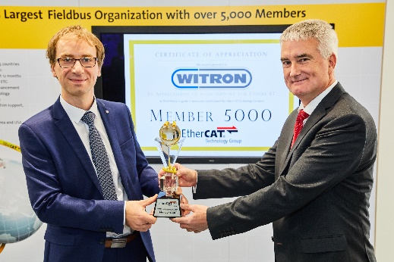
Link: www.ethercat.org/images/press/etg082018.jpg

Picture caption:
Executive Director of ETG Martin Rostan presents WITRON's Josef Uschold with a trophy as a sign of appreciation

About EtherCAT Technology Group (ETG):
The EtherCAT Technology Group is an organization in which key user companies from various industries and leading automation suppliers join forces to support, promote and advance the EtherCAT technology. With over 5,000 members from 65 countries, the EtherCAT Technology Group has become the largest fieldbus organization in the world. Founded in November 2003, it is also the fastest growing fieldbus organization.

About EtherCAT®:
EtherCAT is the Industrial Ethernet technology which stands for high-performance, low-cost, easy to use with a flexible topology. It was introduced in 2003 and has been an international IEC standard and a SEMI standard since 2007. EtherCAT is an open technology: anyone can implement or use it.

- For further information please see: www.ethercat.org

Press contact:
EtherCAT Technology Group
Alina Krüger
Ostendstraße 196
90482 Nuremberg
Germany

Tel.: +49 (911) 5 40 56 226
Fax: +49 (911) 5 40 56 29
a.krueger@ethercat.org
www.ethercat.org/press

